Using G95 to create TRNSYS TYPES

- Download and install G95 from http://www.g95.org/
(Downloads -> binaries, Stable Version 0.91, March 2008, Self-extracting Windows x86, or just click here : http://ftp.g95.org/v0.91/g95-MinGW-41.exe
- Start TRNSYS Simulation Studio and create a Proforma for your type. Be sure to set the type number.
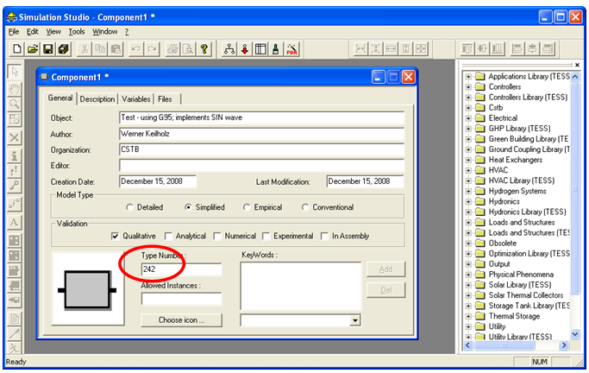
- Save As… .TMF file into .\Trnsys16\Studio\Proformas (or a subdirectory thereof)
- Unzip G95-TRNSYS.zip to a directory you can remember, e.g. \tmp\G95\Type242. It contains slightly modified versions of the TrnsysConstants, TrnsysData and TrnsysFunctions modules.
- Use File/Export As… FORTRAN ; specify the directory you remembered in step 4. Ignore the warnig about Visual FORTRAN not starting (if you have Visual FORTRAN, it may start – just close it again). Ignore the generated .dsw and .opt files.
- Edit the FORTRAN template file produced to implement your type. Make sure continuation lines are preceded by 5 space characters, such as
1 STORED(NSTORED),T(ND),DTDT(ND)
123456
in line 68 of the example.
This convention differs from other compilers.
- Edit the first line of compile.bat to set the correct type number, e.g.
set TRNSYS_TYPE=242
- Copy your TRNDll.Dll (from .\Trnsys16\Exe) to the directory you remembered in step 4.
- Run the Batch file
- Correct the errors you made in the source code and go back to step 8.
- Copy the resulting Dll (still from the directory remembered in step 4), \tmp\G95\Type242\Type242.dll in our example) to .\Trnsys16\Userlib\RekleaseDlls

The Proforma can now be used in a simulation project in Simulation Studio. You can of course automate this using your favourite text editor, for example.

